Capstone Project-I
Report
on

FixMyRoad

Submitted By
Tirth Goti | 202302626010087
Devansh Prajapati | 202302626010102
Ujas Dubal | 202302626010148
Jaimin Solanki | 202302626010152

Under the Guidance of
Ms. Twinkle K. Patel
Assistant Professor



Faculty of Engineering and Technology
GLS University
Academic Year
(2025-2026)



CERTIFICATE

This is to certify that the project report entitled “__FixMyRoad _” has been satisfactorily carried out by the following students

Tirth Goti | 202302626010087
Devansh Prajapati | 202302626010102
Ujas Dubal | 202302626010148
Jaimin Solanki | 202302626010152

under my guidance in the fulfillment of the course Capstone Project-I (222601506) work during the academic year 2025-2026.

(Ms. Twinkle K. Patel) |  | (Dr. Madhuri Chopade)
Internal Guide |  | Capstone Project-I Coordinator

Acknowledgment

We would like to express our sincere gratitude to all those who contributed to the successful completion of our capstone project, FixMyRoad.

First and foremost, we extend our heartfelt thanks to our project guide, Ms. Twinkle K. Patel, for her constant support, valuable guidance, and constructive feedback throughout the development of this project. Her encouragement and insights have been instrumental in shaping our work.

We also wish to thank the faculty members of the Computer Science and Engineering Department for providing us with the necessary academic foundation, resources, and motivation to pursue this project. Their continuous support has helped us understand the practical applications of the concepts learned during our academic journey.

Last but not least, we express our appreciation to our teammates for their cooperation, dedication, and collaborative efforts. The successful progress of this project would not have been possible without the collective contribution of every team member.

Although the project is still under development, the experience gained during its creation has been invaluable, and we look forward to enhancing the system further in the future.

Sincerely,
Tirth Goti (202302626010087)
Devansh Prajapati (202302626010102)
Jaimin Solanki (202302626010174)
Ujas Dubal (202302626010152)

Abstract

Road damage analysis and detection is essential for identifying potholes and surface deterioration that affect transportation safety, vehicle performance, and overall urban mobility. This project, FixMyRoad, aims to detect potholes from road images using deep learning techniques, estimate repair costs based on damage severity, and prioritize reported potholes to support efficient maintenance decision-making. By leveraging YOLOv11 Instance Segmentation and computer vision methods, the system extracts meaningful features from unstructured road images and predicts the likelihood of damage using curated datasets. The system also incorporates geo-tagging to capture the precise location of each detected pothole, enabling accurate mapping and improved coordination for maintenance activities. As potholes remain a persistent global infrastructure challenge impacting public safety, vehicle expenses, and city operations, the need for automated road monitoring systems is increasing. Although the system is still under development, FixMyRoad is expected to offer a proactive, data-driven approach to assist municipal authorities in improving road maintenance efficiency and enhancing transportation safety.

Content

Sr. | Particular | Page No.
 | Certificate | I
 | Acknowledgment | II
 | Abstract | III
 | Table of Content | IV
 | List of Tables | V
 | List of Figures | VI
1. | Introduction | 1
2. | Literature Review | 3
3. | Project Methodology | 8
4. | Project Requirement | 19
5. | Tools & Technologies | 23
6. | Implementation | 24
7. | Conclusion & Future Work | 27
8. | References | 29

List of Tables

Sr. | Particular | Page No.
1. | Table 2.1 Research paper review summary | 4
2. | Table 2.2 Comparative analysis of existing pothole reporting systems | 7
3. | Table 3.1 Data Dictionary | 13

List of Figures

Sr. | Particular | Page No.
1. | Fig 3.1 Class Diagram of FixMyRoad | 10
2. | Fig 3.2 Workflow Diagram of FixMyRoad | 11
3. | Fig 3.3 State Diagram of FixMyRoad | 12
4. | Fig 3.4 Activity Diagram of FixMyRoad | 14
5. | Fig 3.5 Use-case Diagram of FixMyRoad | 15
6. | Fig 3.6 Sequence Diagram of FixMyRoad | 16
7. | Fig 3.7 Data-flow Diagram (Level 2) of FixMyRoad | 17
8. | Fig 3.8 Data-flow Diagram (Level 1) of FixMyRoad | 18
9. | Fig 4.1 sample training image | 21
10. | Fig 4.2 annotated segmentation mask | 21
11. | Fig 4.3 yolov11 segmentation result | 22

Chapter 1: Introduction

  - Context of the Study

Road infrastructure is a fundamental component of transportation systems and plays a crucial role in supporting economic activity, ensuring mobility, and maintaining public safety. However, continuous usage, environmental effects, and lack of timely maintenance often result in potholes and surface deterioration. These issues negatively impact vehicle performance, increase maintenance costs, and pose safety risks to drivers and pedestrians.
Traditional road inspection typically involves manual surveys conducted by municipal staff, which is time-consuming, inefficient, and susceptible to human error. With the growth of smart city initiatives and advancements in artificial intelligence, automated road damage detection has emerged as a more effective and scalable solution. Leveraging computer vision and deep learning enables faster, more accurate pothole detection and supports data-driven road maintenance planning.

  - Problem Statement

Municipal authorities often struggle to maintain roads effectively due to delayed reporting, inefficient inspection methods, and lack of structured prioritization. Manual assessment of road conditions is slow and may overlook critical areas requiring immediate repair. Furthermore, authorities frequently lack tools to estimate repair costs accurately and allocate resources efficiently.

Key challenges include:
- Inefficient manual pothole detection processes
- Lack of automated cost estimation for repair planning
- Absence of systematic prioritization for fixing the most severe potholes first

These challenges highlight the need for an intelligent system that can detect, estimate, and prioritize potholes efficiently.

  - Aim and Objectives

1.3.1 Aim
The aim of this project is to design an AI-based system that can detect potholes, estimate repair costs, and prioritize reported damages for efficient road maintenance.

1.3.2 Objectives
- to segment and detect potholes from road images using YOLOv11 instance segmentation
- to estimate the repair cost based on pothole size and severity
- to arrange all reported potholes in priority order
- to support data-driven decision-making for road maintenance

  - Scope of the Project

The scope of FixMyRoad includes:
- segmenting and detecting potholes using deep learning techniques
- estimating repair cost based on detected damage
- ranking potholes based on severity and urgency
- capturing and storing geo-tagged locations of detected potholes for mapping and reporting

The project is designed to provide an AI-driven approach for pothole monitoring and prioritization. Advanced features such as real-time video detection and government system integration are not included in the current development phase but can be added as future enhancements.

Chapter 2: Literature Review

  - Analysis of Existing Techniques

The reviewed studies show a clear progression from basic image processing approaches to more advanced deep learning-based systems. Traditional methods such as thresholding, edge detection, and classical segmentation were highly sensitive to environmental variations, including lighting changes, shadows, and inconsistent road textures, leading to limited accuracy and reliability. Sensor-based techniques using accelerometers and gyroscopes also produced inconsistent outputs due to variations in vehicle suspension, speed, and hardware placement.

Deep learning introduced significant improvements by enabling automatic feature learning and delivering higher robustness. Models such as CNNs, Faster R-CNN, SSD, and early YOLO versions improved detection accuracy and real-time performance. However, these models were primarily restricted to object detection, providing only bounding boxes without detailed shape or boundary information.

Instance segmentation methods, such as Mask R-CNN, addressed this limitation by producing pixel-level masks of potholes. More recent advancements, particularly YOLOv11 instance segmentation, offer improved accuracy, faster inference, and more precise mask generation than earlier models. This makes YOLOv11 highly suitable for tasks requiring accurate boundary extraction, area measurement, and severity-based repair cost estimation.

Despite these advancements, most existing research still focuses only on detection and lacks important practical features such as repair cost estimation, geo-tagging, and priority-based repair scheduling.

  - Review of Existing Research

Researchers have explored various methods for pothole detection and road surface assessment, ranging from traditional image processing to advanced deep learning techniques. Early studies mainly used classical computer vision algorithms such as edge detection and thresholding, but these techniques were highly sensitive to lighting, shadows, and road texture variations, resulting in inconsistent performance.

With advancements in artificial intelligence, machine learning and deep learning models began to replace traditional methods. CNNs, Faster R-CNN, SSD, and earlier YOLO versions significantly improved accuracy and robustness but were mostly limited to object detection, providing only bounding boxes.

Recent research has shifted toward instance segmentation models like Mask R-CNN, YOLO-Seg, and the latest YOLOv11 instance segmentation, which offer pixel-level segmentation of potholes. This allows for more precise damage identification and supports additional tasks such as area estimation and severity analysis.

In total, 17 research papers were reviewed to understand existing approaches, their strengths, and their limitations, forming the basis for improvements proposed in FixMyRoad.

Table 2.1 Research paper review summary
No. | Title | Year | Method | Challenges
1 | A Review of Vision-Based Pothole Detection Methods Using Computer Vision and Machine Learning | 2024 | Vision-based DL & hybrid models | Lacks depth & diverse datasets
2 | Pothole Detection and Road Damage Assessment System Utilizing Image Processing Techniques | 2024 | 2D image processing techniques | No depth; no GPS/mobile integration
3 | POT-YOLO: Real-Time Road Potholes Detection Using Edge Segmentation-Based YOLOv8 Network | 2024 | YOLOv8 with edge segmentation | Limited validation in real-world settings
4 | Pothole Detection and Filling System Using Image Processing and Machine Learning | 2024 | Image processing + ML-based filling logic | No material estimation; lacks real-world testing
5 | Pothole Detection in Bituminous Road Using CNN with Transfer Learning | 2024 | CNN with transfer learning | No GPS/location tagging; lacks depth info
6 | Pothole Detection Model for Road Safety Using Computer Vision and Machine Learning | 2024 | Classical CV + ML classification | No real-time capability; no material estimation
7 | Pothole Boundary Detection Algorithm Using Image Segmentation Technique in Urban Road | 2025 | Image segmentation | Low boundary accuracy in noisy environments
8 | Pothole Detection Using Image Processing and Machine Learning | 2025 | ML with basic image processing | No GPS; lacks material estimation
9 | Enhancing Automatic Pothole Detection in Non-Motorized Corridors Using Smartphones: An Integrated Algorithm | 2025 | Smartphone-based integrated algorithm | Inconsistent results across different devices
10 | Road Pothole Detection and Reporting System | 2025 | Basic image processing + GPS | No severity detection; no material estimation
11 | Smart Roadway Monitoring: Pothole Detection and Mapping via Google Street View | 2025 | Google Street View + CV mapping | Limited to pre-captured Street View data
12 | Potholes Detection Using Deep Learning and Area Estimation Using Image Processing | 2021 | Deep learning + image-based area calculation | Limited real-time validation; accuracy drops
13 | Pothole Detection Using Location-Aware Convolutional Neural Networks | 2020 | Location-aware CNN | High computational cost; not mobile-friendly
14 | Enhancing Road Safety: Pothole Detection Using YOLOv8 Deep Learning Model | 2024 | YOLOv8 | Limited validation across varied road conditions
15 | Pothole Detection with YOLOv8 | 2023 | YOLOv8 | High computation; lacks depth/material data
16 | AI-Driven Vision-Based Pothhole Detection for Improved Road Safety | 2025 | Vision-based AI model | No GPS/data reporting; lacks repair estimation
17 | Real-Time Deep Learning-Based Pothole Detection on Low-Cost Embedded Devices for ADAS | 2025 | DL on low-cost embedded devices | Limited accuracy; no material estimation

  - Identified research gaps

The literature review highlights several key limitations in existing pothole detection systems:
- most models perform only detection and lack pixel-level segmentation
- repair cost estimation based on pothole area or severity is rarely addressed
- geo-tagging and accurate location reporting are missing in many approaches
- priority-based repair scheduling is not integrated into most systems
- limited real-world validation reduces reliability and generalization

These gaps indicate the need for a comprehensive solution that combines segmentation, cost estimation, geo-tagging, and prioritization—capabilities addressed by FixMyRoad.

  - Comparative analysis of existing systems

To better understand the practical limitations of currently deployed pothole reporting applications, a comparison was conducted between FixMyRoad and two widely used systems: BBMP Fix Pothole and Meri Sadak. The comparison highlights the absence of AI-based detection, dimension estimation, repair material estimation, and automated prioritization in existing solutions.

Table 2.2 Comparative analysis of existing pothole reporting systems
Feature | FixMyRoad | BBMP Fix Pothole | Meri Sadak
AI-based detection | ✔ | ✖ | ✖
Dimension/volume estimation | ✔ | ✖ | ✖
Automated repair material estimation | ✔ | ✖ | ✖
Real-time geo-tagging | ✔ | ✔ | ✔
Actionable alerts to authorities | ✔ | ✔ | ✔

  - Conclusion of literature review

This chapter reviewed existing pothole detection techniques, related research studies, and current reporting applications. The analysis highlighted limitations such as lack of segmentation, repair cost estimation, geo-tagging, and prioritization. These gaps justify the need for a more comprehensive solution like FixMyRoad.

Chapter 3: Project Methodology

  - System overview

FixMyRoad is an AI-based system designed to automate pothole detection, severity analysis, repair cost estimation, and maintenance prioritization. The process begins with capturing road images and recording their geo-tagged locations. These images are analyzed using YOLOv11 instance segmentation to obtain pixel-level pothole boundaries.

To enhance accuracy, the system uses the MiDaS depth model to estimate pothole depth from the segmented region. The combined area and depth data are used to calculate pothole volume and estimate repair cost based on standard material and labor requirements. Each pothole is then assigned a priority score according to its severity, location importance, and repair cost, helping authorities schedule maintenance efficiently.

FixMyRoad integrates geo-tagging, segmentation, depth estimation, cost calculation, and prioritization into a unified, intelligent workflow for effective road maintenance.

  - System architecture

The architecture of FixMyRoad is designed as a modular and sequential pipeline where each component performs a dedicated role in pothole detection, analysis, and prioritization. The system integrates image processing, instance segmentation, depth estimation, and decision-making logic to deliver a complete AI-driven road maintenance solution.

3.2.1 Image Capture & Geo-Tagging Module
- Road images are captured using a mobile device or camera, and GPS coordinates are automatically recorded at the time of capture. This ensures every detected pothole is accurately mapped to its real-world location and supports location-based reporting.
3.2.2 Preprocessing Module
- Captured images are standardized through resizing, noise reduction, and color normalization. These steps enhance image quality and improve the performance of segmentation and depth estimation models.

3.2.3 YOLOv11 Instance Segmentation Module
- The preprocessed image is passed to the YOLOv11 instance segmentation model, which identifies potholes and generates pixel-level masks. These masks accurately outline the pothole shape and serve as the foundation for area and depth calculations.
3.2.4 MiDaS Depth Estimation Module
- The segmentation mask is processed by the MiDaS depth model to generate a relative depth map. This helps estimate how deep the pothole is compared to the surrounding surface and supports accurate severity assessment.
3.2.5 Damage Analysis Module
- Using the segmentation mask and depth map, the system calculates key metrics such as pothole area, relative depth, estimated volume, and assigns a severity category (low, moderate, or severe).
3.2.6 Repair Cost Estimation Module
- Repair cost is estimated based on pothole volume and standard patching rates. Material quantity, labour requirements, and municipal repair rates are combined to generate an approximate repair cost.
3.2.7 Priority Ranking Module
- Each pothole is assigned a priority score by considering severity, repair cost, location importance and safety impact. Higher-impact potholes receive higher priority for maintenance.
3.2.8 Data Storage & Reporting Module
- All results—including geo-tag, segmentation mask, depth values, severity, estimated repair cost, and priority score—are stored in a structured database. This data can be used to generate reports, export summaries, or visualize potholes on a map.

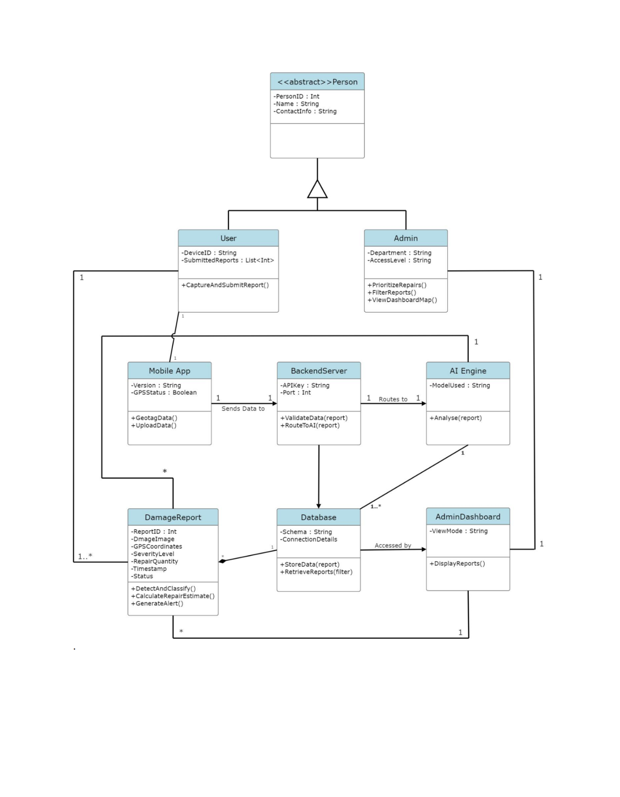
Fig 3.1 Class Diagram of FixMyRoad
  - Workflow of FixMyRoad

The workflow of FixMyRoad follows a structured sequence of operations designed to detect potholes, analyze their severity, estimate repair cost, and assign a priority score for effective maintenance planning. Each stage contributes to the overall automation of road damage assessment. The complete workflow is described below:
- Image Capture
A road image is captured using a mobile device or camera.
- Geo-Tagging
GPS coordinates are automatically recorded and linked with the image.
- Image Preprocessing
The image is resized, cleaned, and normalized to prepare it for analysis.
- Pothole Segmentation
YOLOv11 instance segmentation identifies the pothole and generates a pixel-level mask.
- Depth Estimation
The segmentation mask is passed to the MiDaS model to estimate the relative depth of the pothole.
- Damage Analysis
The system calculates pothole area, depth, volume, and assigns a severity level.
- Repair Cost Estimation
Using standard repair rates and material requirements, the system estimates the repair cost.
- Priority Assignment
Potholes are ranked based on severity, location importance, and repair cost.
- Data Storage
All results—including geo-tag, severity, cost, and priority—are stored for reporting and visualization.
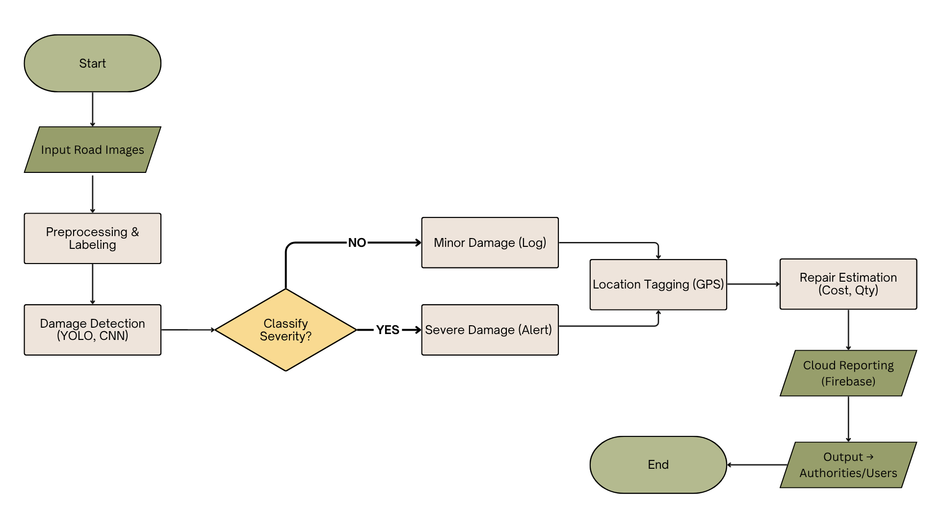
Fig 3.2 Workflow Diagram of FixMyRoad
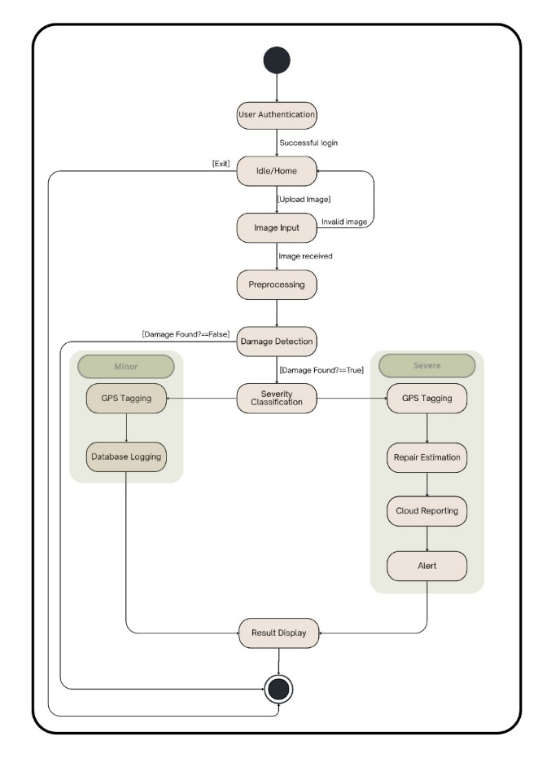
Fig 3.3 State Diagram of FixMyRoad
  - Dataset description and preprocessing

The dataset used for FixMyRoad consists of over 2000 real-world road images captured from different locations and environments. These images include potholes of various shapes, sizes, lighting conditions, and road textures, allowing the model to generalize well across diverse scenarios. The dataset also includes additional samples collected from publicly available sources to further improve robustness.
Dataset Repository: Google Drive

Before training, all images undergo preprocessing. Each image is resized to match the input requirements of YOLOv11 and MiDaS. Noise reduction and normalization techniques are applied to improve visual clarity. Data augmentation methods such as rotation, flipping, cropping, and brightness adjustment are used to increase dataset diversity and reduce overfitting. Potholes in the training dataset are annotated using segmentation masks to enable precise pixel-level learning for YOLOv11 instance segmentation. Depth data is standardized to ensure compatibility with the MiDaS depth estimation module.

Table 3.1 Data Dictionary
No. | Data Element | Description / Purpose | Data Type | Source / Input | Usage / Destination
1 | User_ID | Unique identifier for each registered user | Integer / String | User Registration | Firebase / Authentication
2 | User_Name | Name of the user | String | User Input | Reports, Logs
3 | Email_ID | User’s email for login and alerts | String | User Input | Login, Notification
4 | Image_File | Uploaded road image for analysis | Image (JPG/PNG) | User Device | Preprocessing Module
5 | Image_ID | Unique ID for each uploaded image | Integer | Auto-generated | Database
6 | Damage_Type | Type of detected damage (crack, pothole, etc.) | String | Detection Model | Report Generation
7 | Severity_Level | Damage severity level (Minor/Severe) | Enum | Classification Model | Estimation / Alert
8 | Latitude | GPS latitude of damage location | Float | GPS Sensor | Firebase / Map
9 | Longitude | GPS longitude of damage location | Float | GPS Sensor | Firebase / Map
10 | Repair_Cost | Estimated repair cost | Float | Estimation Module | Report / Notification
11 | Material_Quantity | Estimated material needed | Float | Estimation Module | Report
12 | Alert_Status | Indicates if alert sent to authority | Boolean | System Process | Firebase
13 | Report_ID | Unique identifier for each generated report | String | System | Firebase / User Display
14 | Report_URL | URL link to report or result image | String (URL) | Firebase Storage | User Interface

  - Geo-tagging and location recording

Geo-tagging is performed at the moment an image is captured. The mobile device automatically records the GPS coordinates, including latitude and longitude, using its built-in location services. This information is linked with each image before any further processing begins.

The recorded coordinates help correctly identify the real-world location of every pothole detected by the system. Geo-tagging enables accurate mapping, assists in visualizing pothole clusters, and supports maintenance teams in planning site visits. The geo-tagged data also forms the basis for spatial analysis, reporting, and location-based prioritization of pothole repairs.
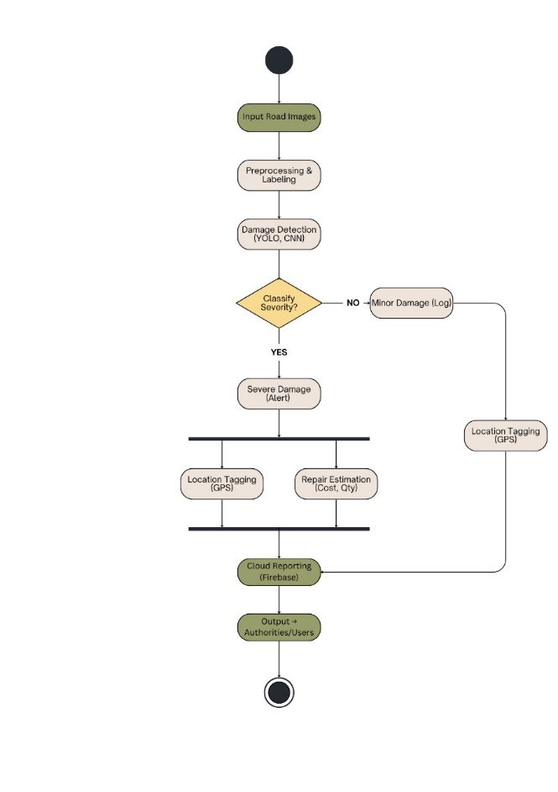
Fig 3.4 Activity Diagram of FixMyRoad
  - Model selection and training

YOLOv11 instance segmentation is used as the primary model for pothole detection due to its high accuracy, fast inference speed, and ability to generate pixel-level masks. Unlike basic object detection models that only draw bounding boxes, YOLOv11 provides detailed region-based segmentation, which is essential for precise area measurement and depth analysis in real road inspection scenarios.

For depth estimation, the MiDaS model is selected because it can generate relative depth information from a single 2D image without requiring specialized sensors. MiDaS enhances the segmentation output by providing depth variations inside the pothole region, allowing more accurate severity and volume estimation.

The training process includes preparing segmentation mask annotations, splitting the dataset into training, validation, and testing sets, and training YOLOv11 with optimized hyperparameters such as learning rate, batch size, and epochs. Data augmentation is applied to improve robustness under different lighting and road conditions.

After training, YOLOv11 segmentation and MiDaS depth estimation are combined to perform real-time pothole detection, depth analysis, and damage evaluation, producing reliable outputs for the later stages of the system.
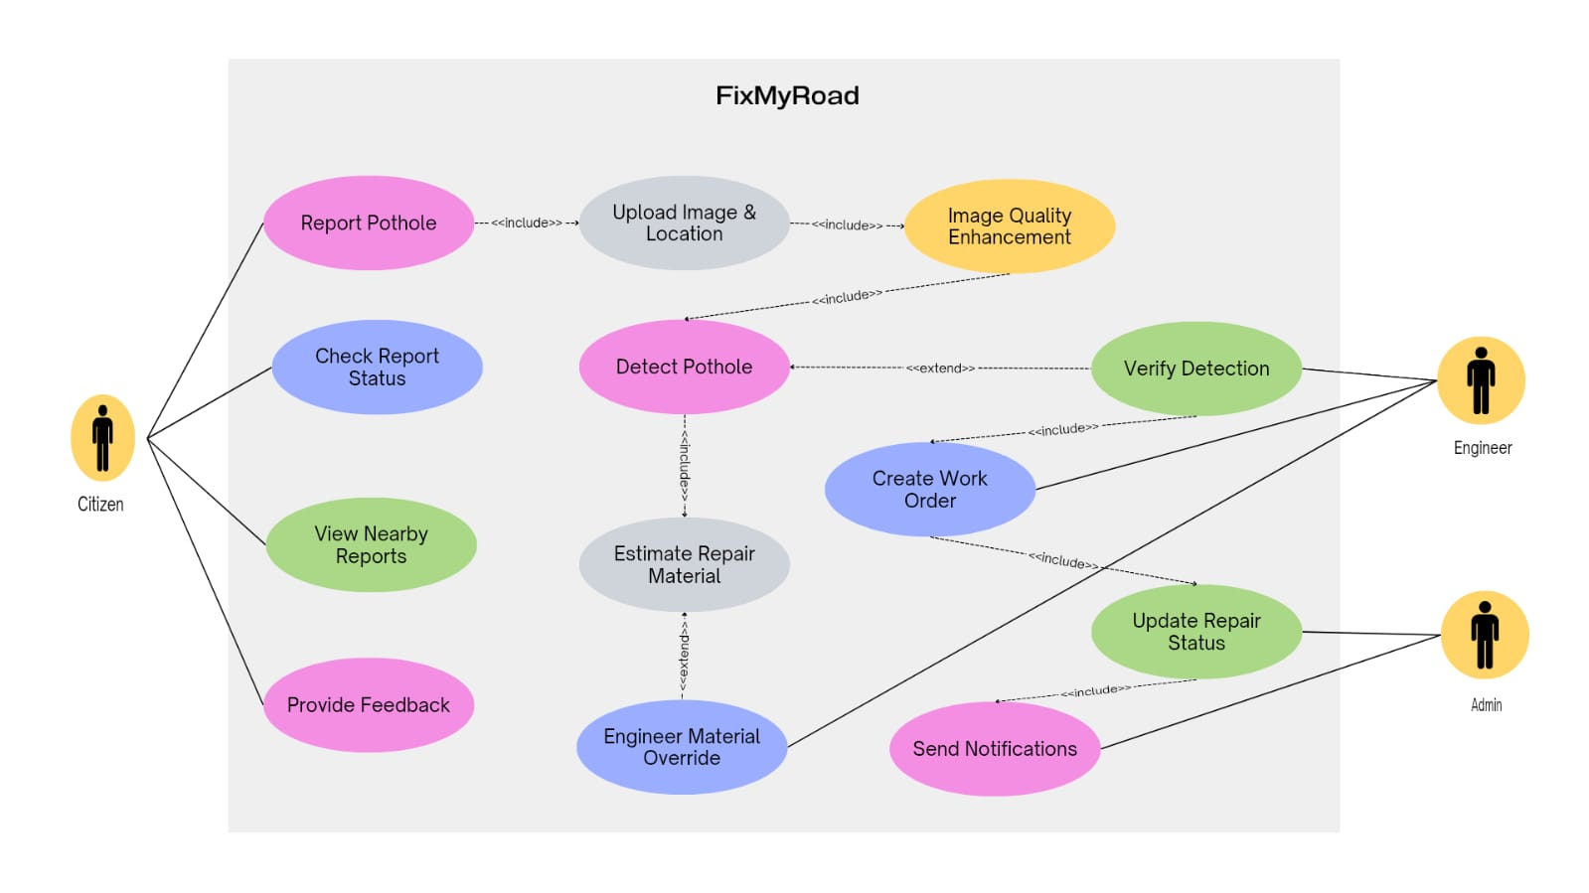
Fig 3.5 Use-case Diagram of FixMyRoad
  - Pothole area measurement and severity calculation

After segmentation and depth estimation, FixMyRoad performs damage analysis to calculate the pothole’s area, depth, volume, and severity. The segmentation mask generated by YOLOv11 provides precise pixel boundaries, which are converted into real-world dimensions to compute the pothole area.

The MiDaS model generates a relative depth map, and depth values within the segmented region are used to estimate the average depth and depression level. Combining area and depth allows the system to approximate the pothole volume, which is essential for determining severity and repair cost.

Based on area, depth, and volume, the system categorizes potholes into severity levels such as low, moderate, or severe. Higher severity indicates deeper or larger potholes that require quicker intervention. This classification enables authorities to identify critical damages and plan repairs efficiently.
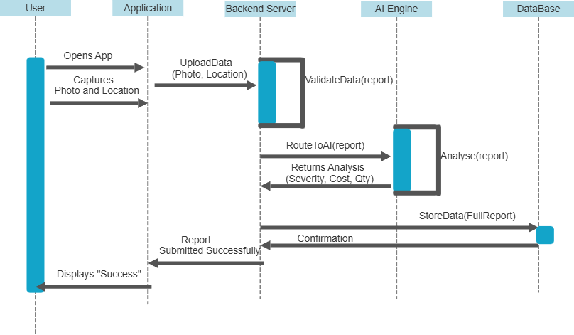
Fig 3.6 Sequence Diagram of FixMyRoad
  - Repair cost estimation

Repair cost estimation is performed using the calculated pothole area, depth, and volume derived from segmentation and depth analysis. The system estimates the amount of material required to fill the pothole by using the computed volume. Standard municipal patching rates and material costs are applied to convert the material requirement into a cost estimate.
The cost calculation also considers additional factors such as labor charges and equipment usage. By combining these parameters, the system generates an approximate repair cost for each pothole. This cost estimate helps municipal authorities in budgeting, resource allocation, and planning large-scale road maintenance operations. The automated estimation process ensures consistency and reduces the dependency on manual inspection or subjective judgment.

  - Priority assignment logic

After estimating severity and repair cost, FixMyRoad assigns a priority score to each pothole to help authorities determine which locations require immediate attention. The priority assignment is based on a combination of critical factors that influence road safety and maintenance urgency.

The priority score is computed by evaluating the following parameters:
- Severity Level
Potholes classified as severe, with large area or greater depth, receive a higher priority, as they pose greater safety risks.
- Estimated Repair Cost
Higher-cost potholes may indicate larger or more complex damage. Such potholes are prioritized for timely intervention to prevent further deterioration and increased repair expenses.
- Location Importance
Potholes on main roads, highways, school zones, or high-traffic areas are prioritized over those in low-traffic residential streets, as they affect more commuters.
- Safety Impact
Potholes that could cause significant accidents, vehicle damage, or obstruction of road flow are given urgent priority.

Based on these factors, the system assigns each pothole a priority category such as high, medium, or low. This structured prioritization helps municipal authorities plan maintenance activities efficiently, ensuring that the most critical potholes are addressed first.
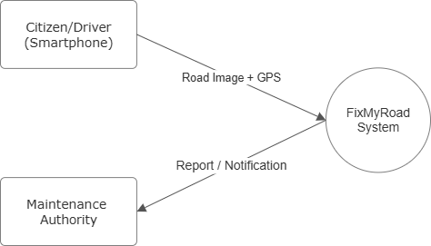
Fig 3.7 Data-flow Diagram (Level 2) of FixMyRoad

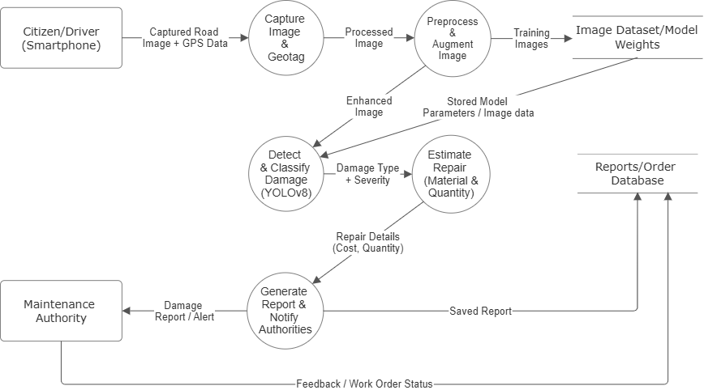
Fig 3.8 Data-flow Diagram (Level 1) of FixMyRoad

Chapter 4: Project Requirements

Functional requirements

Functional requirements describe the core operations that FixMyRoad must perform to achieve its objectives. These requirements define what the system should do and outline the essential features needed for pothole detection, analysis, and reporting. The functional requirements of the project are as follows:

- Image Capture
The system must allow users to capture or upload road images containing potholes.
- Geo-Tagging
The system must automatically record GPS coordinates (latitude and longitude) at the time of image capture or upload.
- Image Preprocessing
The system must preprocess images through resizing, normalization, and noise reduction to ensure consistent input quality.
- Pothole Segmentation
The system must detect and segment potholes using the YOLOv11 instance segmentation model, generating pixel-level boundaries.
- Depth Estimation
The system must estimate relative depth using the MiDaS model to support severity and volume calculations.
- Damage Analysis
The system must compute pothole area, average depth, and estimated volume based on segmentation and depth data.
- Severity Classification
The system must categorize potholes into severity levels such as low, moderate, or severe.
- Repair Cost Estimation
The system must estimate repair cost using pothole volume, material requirements, and standard patching rates.
- Priority Ranking
The system must assign a priority score to each pothole by considering severity, cost, and location importance.
- Data Storage and Reporting
The system must store all processed information and generate reports or visual outputs for decision-making.

Non-functional requirements

Non-functional requirements describe the quality standards, performance expectations, and operational constraints that the FixMyRoad system must satisfy. These requirements ensure that the system not only performs its functions but also delivers them efficiently, securely, and reliably.

- Performance
The system should process each image within a reasonable time, ensuring smooth detection, analysis, and result generation.
- Accuracy
YOLOv11 and MiDaS models should provide reliable segmentation and depth estimation with high precision to ensure correct severity and cost calculations.
- Usability
The system interface should be simple, intuitive, and easy for users to operate while capturing images or viewing analysis results.
- Scalability
The system should support an increasing number of images, larger datasets, and model upgrades without significant performance degradation.
- Reliability
The system should consistently perform segmentation, depth estimation, and data processing without errors or interruptions.
- Maintainability
The system should be designed in a modular manner, allowing easy maintenance, updates, and improvements in individual components.
- Portability
The solution should run on various devices and platforms, including laptops and mobile devices used for image capture.
- Security
All stored data, especially geo-tagged locations, should be protected against unauthorized access, ensuring privacy and data integrity.

4.3 Prototype with screenshots

The current prototype of FixMyRoad focuses solely on pothole detection using YOLOv11 instance segmentation. As the project is still in development, only the segmentation model has been implemented and tested on a dataset of 150 images.

The following screenshots represent the outputs generated during dataset preparation and model testing.

- Sample Training Image
A sample road image from the dataset used to train the YOLOv11 segmentation model.

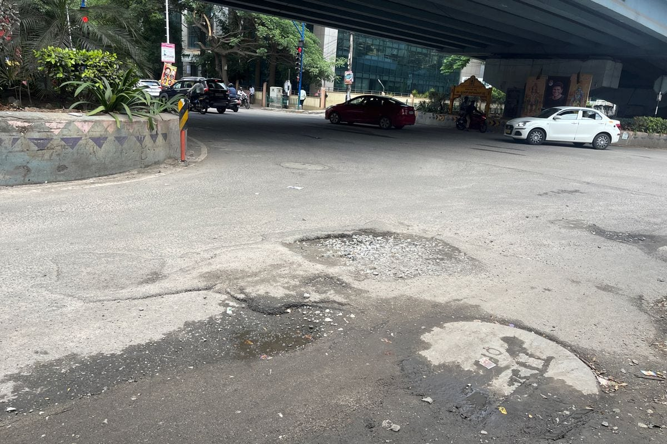
Fig 4.1 Sample training image

- Annotated Segmentation Mask
The manually annotated segmentation mask from the training dataset showing pothole boundaries.

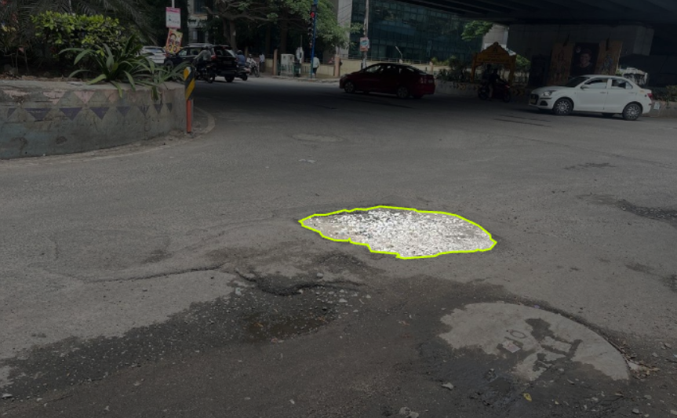
Fig 4.2 Annotated segmentation mask
- YOLOv11 Segmentation Output
The model-generated segmentation output, displaying pixel-level pothole detection after training.
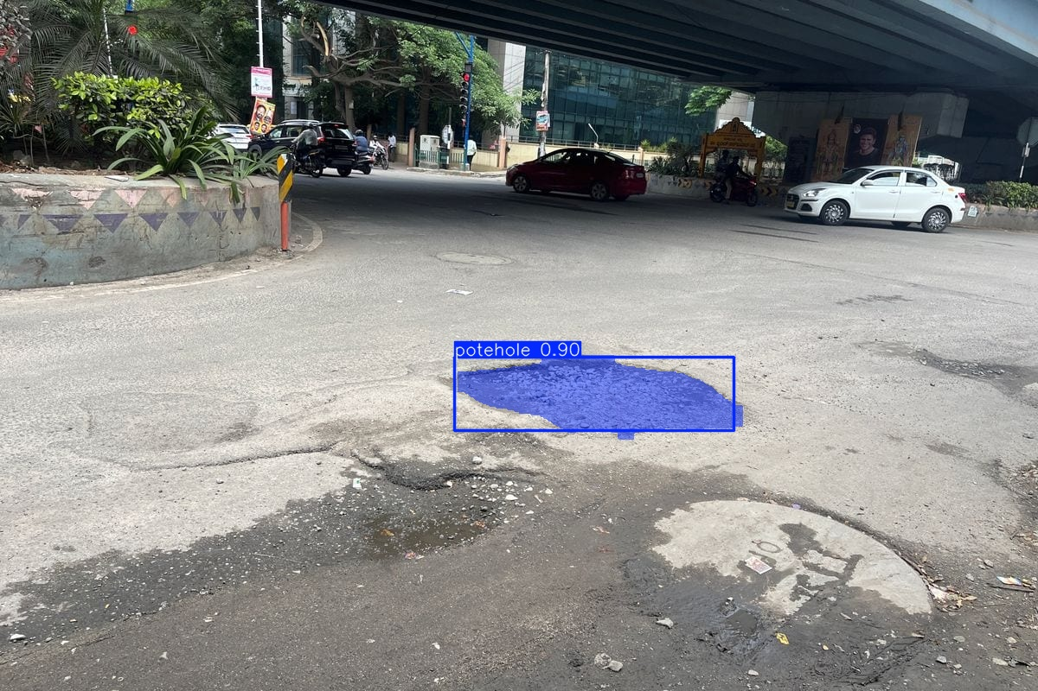
Fig 4.3 YOLOv11 segmentation result

Chapter 5: Tools & Technologies

FixMyRoad uses a combination of AI models, programming tools, and software libraries to implement pothole detection, depth estimation, analysis, and reporting. The major tools and technologies used in the system are listed below:

- Programming Language
• Python – used for model training, data processing, analysis, and backend logic.
- Deep Learning Models
• YOLOv11 Instance Segmentation – used for pixel-level pothole detection and boundary extraction.
• MiDaS Depth Estimation – used to compute relative depth from 2D images.
- Libraries and Frameworks
• PyTorch – for training YOLOv11 and MiDaS models
• OpenCV – for image preprocessing and visualization
• NumPy – numerical operations and array handling
• Pandas – data handling and result storage
• Matplotlib – plotting and analysis (optional)
- Annotation and Dataset Tools
• Roboflow – for segmentation mask annotation
• Google Drive – for dataset storage and access
- Hardware
• GPU-enabled system – used to train YOLOv11 efficiently
• Mobile device – used for capturing road images with geo-tagging
- Development Environment
• Jupyter Notebook – for model training and experimentation
• Google Colab – for cloud-based training and testing

These tools collectively support the development, training, evaluation, and deployment of the FixMyRoad system.

Chapter 6: Implementation

Introduction
The implementation of FixMyRoad is currently in its initial phase, focusing on pothole detection using YOLOv11 instance segmentation. This chapter describes the components that have been implemented so far and outlines the modules that will be added in the next stages of development. The fully completed system will include geo-tagging, depth estimation using MiDaS, repair cost calculation, and priority assignment, but these components are planned for future implementation.

6.2 Current implementation status
At present, the following component is fully implemented:
YOLOv11 Instance Segmentation for Pothole Detection
• 150 real-world images were collected and manually annotated
• Model trained using Ultralytics YOLO framework
• Pixel-level masks generated for accurate pothole boundaries
• Segmentation results tested on both images and videos
This module forms the core detection engine of FixMyRoad.

6.3 Dataset preparation
• Over 150 real-world road images
• Exported in YOLO Segmentation format
• Stored on Google Drive
• Includes potholes of different shapes, sizes, and lighting conditions
Annotation was performed using tools such as Roboflow.

6.4 Environment setup
Development and training were carried out in:
• Google Colab
• Python 3
• PyTorch backend
• Ultralytics YOLO library

6.5 Model training process
YOLOv11 instance segmentation was trained using the following configuration:
• batch size: depends on GPU
• automatic augmentation
• segmentation masks as labels
• training loss graphs
• validation metrics
• confusion matrix
• predicted segmentation masks

6.6 Testing & evaluation
Testing was performed on unseen images and videos.
• Model detected potholes and produced pixel-level segmentation
• Results were saved for visualization
• Confusion matrix used for performance evaluation
• Model accuracy currently moderate due to limited dataset size

6.7 Planned future implementation
The following modules will be developed in the next stages:
1. Geo-Tagging & Location Recording
• Automatic GPS capture
• Link every detected pothole to a real-world location
• Useful for mapping & reporting
2. MiDaS Depth Estimation
• Estimate pothole depth from 2D images
• Enables more accurate severity analysis
3. Volume & Severity Calculation
Using segmentation mask + depth map to compute:
• area
• average depth
• approximate volume
• severity level
4. Repair Cost Estimation
• Cost = material volume + standard road repair rates
• Helps municipal authorities estimate budget
5. Priority Ranking System
Based on:
• severity
• location importance
• repair cost
• safety risk
6. Reporting & Storage Module
• Store results in a structured database
• Export reports for municipal use

Chapter 7: Conclusion and Future Work

7.1 Conclusion

FixMyRoad is an AI-driven system designed to automate the process of identifying and analyzing road potholes. In its current phase, the project successfully implements YOLOv11 instance segmentation to detect potholes at a pixel level using a custom dataset of annotated road images. The initial prototype demonstrates the potential of deep learning models to accurately identify pothole regions, enabling automated road damage monitoring.

The results indicate that YOLOv11 performs well for background classification and can detect potholes with moderate accuracy. The segmentation outputs and confusion matrix highlight that the model can effectively identify pothole boundaries but requires a larger and more diverse dataset for improved performance. Overall, the implementation validates the feasibility of using AI-based segmentation models as a core component of automated road maintenance systems.

FixMyRoad lays the foundation for a complete end-to-end pothole analysis system that can support municipal authorities in making data-driven maintenance decisions.

7.2 Future work

The current prototype includes only the segmentation model. The full FixMyRoad system will integrate additional components to create a comprehensive pothole analysis and reporting platform. Planned future enhancements include:

7.2.1 Geo-Tagging and Location Mapping
Integrate GPS-based location capture for every detected pothole to enable:
• map visualization
• clustering of potholes
• automated location-based reporting

7.2.2 Depth Estimation using MiDaS
Implement MiDaS to estimate relative pothole depth from 2D images, enabling:
• depression measurement
• severity classification
• volume calculation

7.2.3 Area, Volume, and Severity Calculation
Combine segmentation masks with depth values to compute:
• real-world area
• approximate pothole volume
• severity categories (low, medium, high)

7.2.4 Repair Cost Estimation
Develop a module to calculate cost based on:
• pothole volume
• material requirement
• standard repair rates
• labour estimations

7.2.5 Priority Assignment System
Create an AI-assisted scoring system considering:
• severity
• location importance (e.g., highways, school zones)
• repair cost
• safety impact
This helps authorities fix the most critical potholes first.

7.2.6 User Interface / Mobile Application
Design a web/mobile interface to allow:
• capturing images directly
• visualizing detected potholes on a map
• generating downloadable reports
• enabling citizen-based reporting

7.2.7 Model Improvement
• expand dataset to 2000+ images (as planned)
• improve annotations for better mask quality
• train longer with optimized hyperparameters
• test on real-time video for better generalization
Chapter 8: References

- Safyari, Y., Mahdianpari, M., & Shiri, H. (2024). A review of vision-based pothole detection methods using computer vision and machine learning. Sensors, 24(17), 5652.
- Swathika, R., & Radha, N. (2024, June). Pothole Detection and Road Damage Assessment System Utilizing Image Processing Techniques. In 2024 Second International Conference on Inventive Computing and Informatics (ICICI) (pp. 269-278). IEEE.
- Bhavana, N., Kodabagi, M. M., Kumar, B. M., Ajay, P., Muthukumaran, N., & Ahilan, A. (2024). POT-YOLO: Real-time road potholes detection using edge segmentation-based YOLO V8 network. IEEE Sensors Journal, 24(15), 24802-24809.
- Mahalingesh, T. C., Mishra, H., Arun, R. V., & Anand, A. (2024, May). Pothole Detection and Filling System Using Image Processing and Machine Learning. In 2024 International Conference on Smart Systems for applications in Electrical Sciences (ICSSES) (pp. 1-5). IEEE.
- Vinodhini, K. A., & Sidhaarth, K. R. A. (2024). Pothole detection in bituminous road using CNN with transfer learning. Measurement: Sensors, 31, 100940.
- Bidve, V. S., Kakade, K. S., Bhole, R. H., Sarasu, P., Shaikh, A., Mehta, P. S., ... & Kediya, S. O. (2024). Pothole detection model for road safety using computer vision and machine learning. Int J Artif Intell ISSN, 2252(8938), 4481.
- Alshami, A. M., Shah, H. N. M., Abdollah, M. F., Ab Rashid, M. Z., & Arshad, M. A. (2025). Pothole Boundary Detection Algorithm using Image Segmentation Technique in Urban Road. Journal of Advanced Research Design, 132(1), 66-77.
- Martins, W. D. A., Osorio, F. S., & Bruno, D. R. (2025, April). Real Time Deep Learning Based Pothole Detection on Low Cost Embedded Devices for ADAS. In 2025 Brazilian Conference on Robotics (CROS) (Vol. 1, pp. 1-6). IEEE.
- Aswanandini, G., Kumar, A. V. S. C., Ravikishor, A., Chandra, C. D., & Reddy, N. S. (2025, April). Pothole Detection Using Image Processing and Machine Learning. In 2025 International Conference on Computing and Communication Technologies (ICCCT) (pp. 1-8). IEEE.
- Qiao, Y., Wang, J., Zhang, X., Huang, J., He, L., & Zhang, R. (2025). Enhancing automatic pothole detection in non-motorized corridors using smartphones: an integrated algorithm. Measurement Science and Technology, 36(3), 036009.
- Ali, S., Xu, M., & Kwak, D. (2025, April). Smart Roadway Monitoring: Pothole Detection and Mapping via Google Street. In Internet Computing and IoT and Embedded Systems, Cyber-physical Systems, and Applications: 25th International Conference, ICOMP 2024, and 22nd International Conference, ESCS 2024, Held as Part of the World Congress in Computer Science, Computer Engineering and Applied Computing, CSCE 2024, Las Vegas, NV, USA, July 22–25, 2024, Revised Selected Papers (Vol. 2260, p. 151). Springer Nature.
- Kharel, S., & Ahmed, K. R. (2021, August). Potholes detection using deep learning and area estimation using image processing. In Proceedings of SAI Intelligent Systems Conference (pp. 373-388). Cham: Springer International Publishing.
- Chen, H., Yao, M., & Gu, Q. (2020). Pothole detection using location-aware convolutional neural networks. International journal of machine learning and cybernetics, 11(4), 899-911.
- Kumar, A. N., Akilandeswari, J., Mathangi, P. R., Prabhu, S. D., Kavya, P., & Ashwin, K. V. (2024, May). Enhancing Road Safety: Pothole Detection and Traffic Efficiency using YOLOv8 Deep Learning Model. In International Conference on Security, Surveillance and Artificial Intelligence (ICSSAI-2023) (pp. 215-223). CRC Press.
- Addanki, A., & Lin, J. (2023). Pothole detection with YOLOV8.
- Rasee, M. A., Ling, U. L., Tan, G. J., Wee, T. C., Buking, R., Yahya, N., & Ismail, H. (2025). AI-driven Vision-based Pothole Detection for Improved Road Safety. Pertanika Journal of Science & Technology, (3).

